NYNGAN MARKETS
SATURDAY 1OTH JUNE 2017
VISITOR NFORMATION CENTRE CARPARK
10AM TIL 1PM
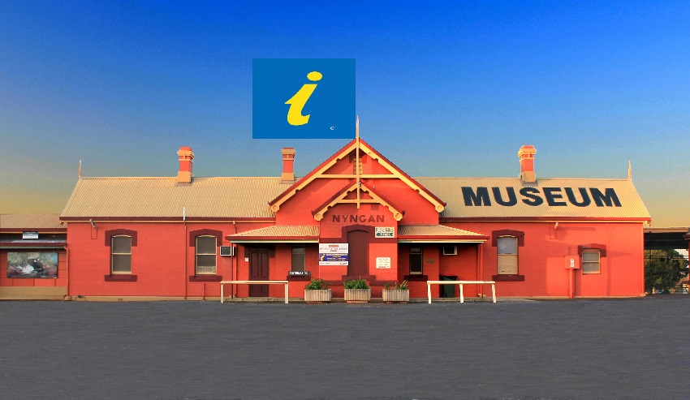
Stall holders please book by Monday 5/6/17
For more info contact Bogan Shire Council
Community Development on 0268359000
Or nynganvic@bogan.nsw.gov.au

